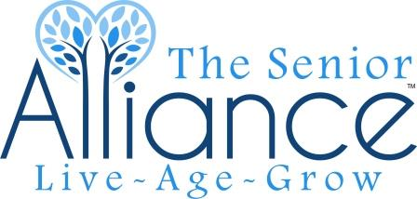

Programmatic Quarterly Report Instructions

- Programmatic Quarterly Reports are due by the 10th of the month following the end of each fiscal quarter (January, April, July, and October).

- Reports must be emailed to ewright@thesenioralliance.org. All reports must be received by the 10th of the month of which they are due. If the 10th falls on a weekend or holiday, reports are due by noon on the next business day. All documents must be typed and properly dated.

- All reports must include the following:

  - Quarterly Narrative
  - Unduplicated Client and Unit Count Quarterly Report
  - Unduplicated Client Count by Community

- All Quarterly Report forms and instructions may be accessed on The Senior Alliance’s website at https://thesenioralliance.org/.

- Questions about how to complete the programmatic Quarterly Reports should be directed to the Contracts Manager at ewright@thesenioralliance.org.

- Late and incomplete reports are compliance issues and can affect funding. Reports that are incomplete will be returned to the contractor. All report corrections are due back to TSA within 14 calendar days or your next payment will be delayed.

Revised 1/24/2022

